Writing Efficient Code

TASK 5:
import java.util.*;

public class Solution {
public static void main(String[] args) {
Scanner sc = new Scanner(System.in);

String s = sc.nextLine();

String period = s.substring(8);
int hour = Integer.parseInt(s.substring(0, 2));

if (period.equals("AM")) {
if (hour == 12) {
hour = 0;
}
} else {
if (hour != 12) {
hour += 12;
}
}

System.out.println(String.format("%02d", hour) + s.substring(2, 8));

sc.close();
}
}
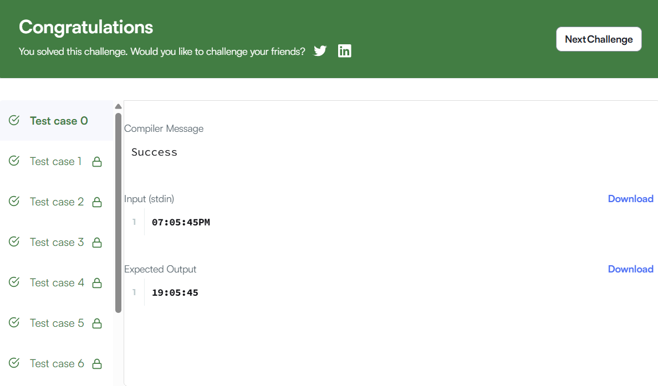

TASK 6:
class Solution {
public void moveZeroes(int[] nums) {
int j = 0;

for (int i = 0; i < nums.length; i++) {
if (nums[i] != 0) {
int temp = nums[i];
nums[i] = nums[j];
nums[j] = temp;
j++;
}
}
}
}
